1. Demonstrate the transmission of message using MQTT protocol in Azure

i) Create the IOT Hub in Azure.

ii) Connect MQTT client to IOT Hub and send a message.

Create the IOT hub on Azure, search IOT hub and click on create option.

Enter the IOT hub name &other details ,Click networking.

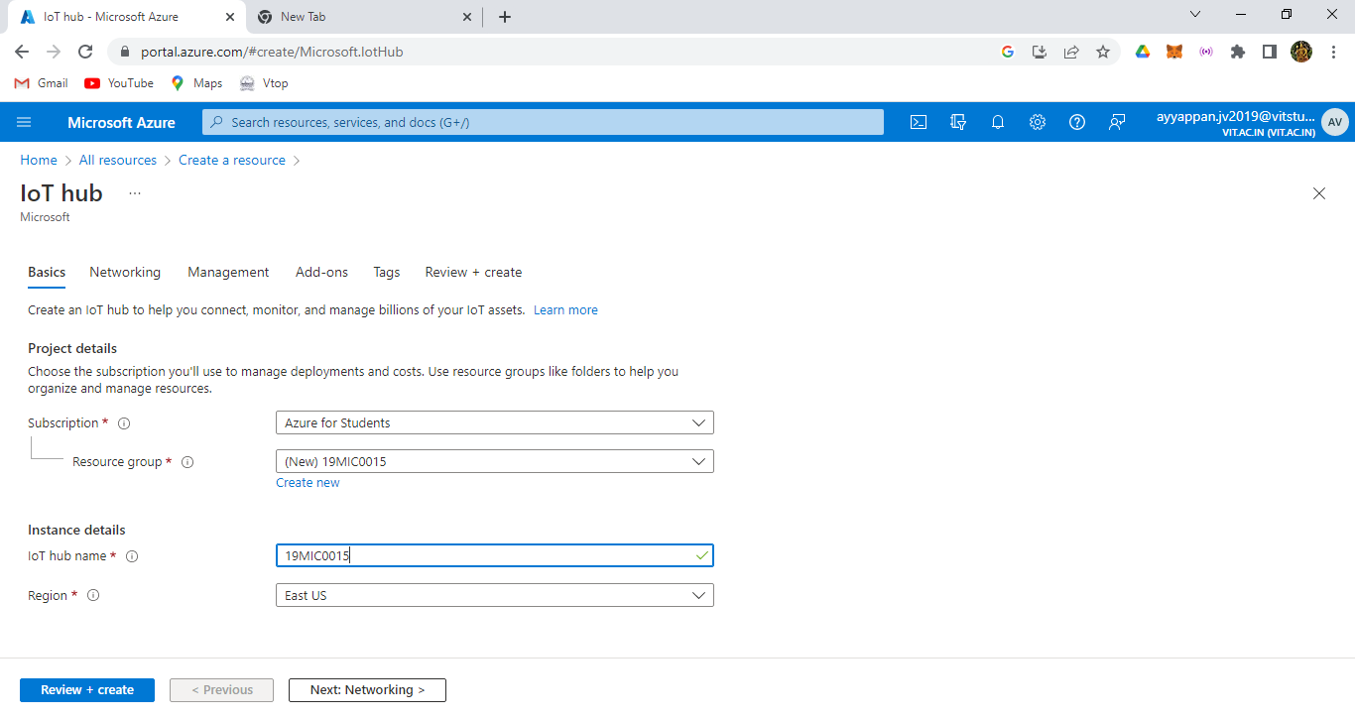

Here we have public access in the networking part of IOT hub.

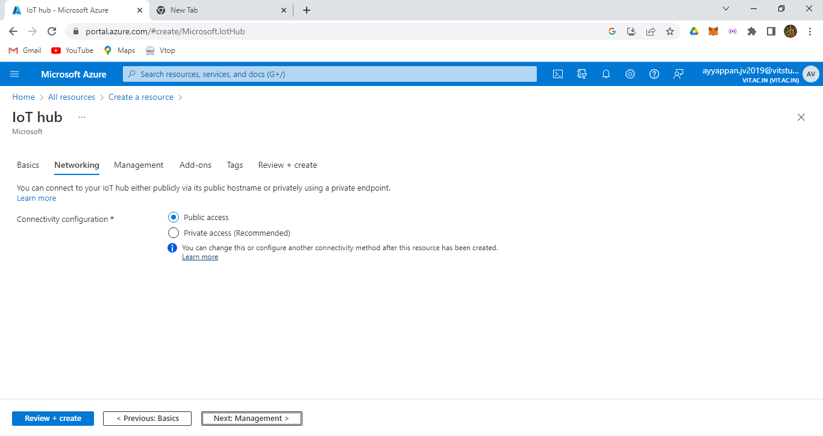

Click next, we have prices scale user list and We have selected the S1 standard tier, click next.

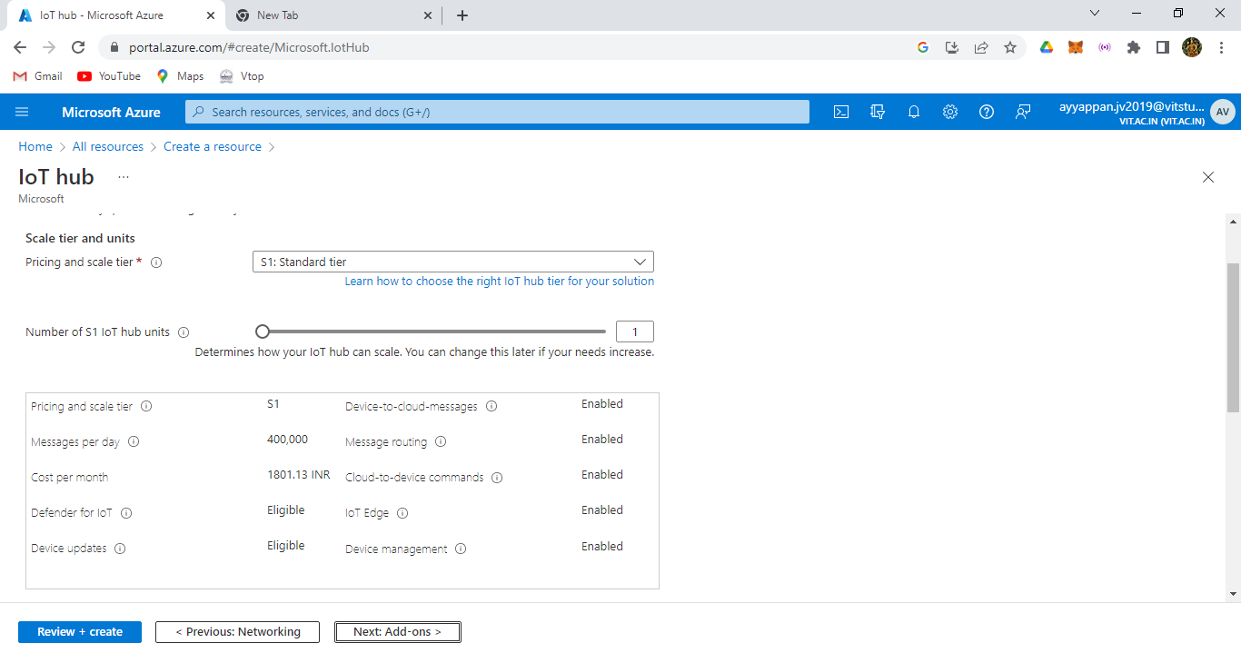

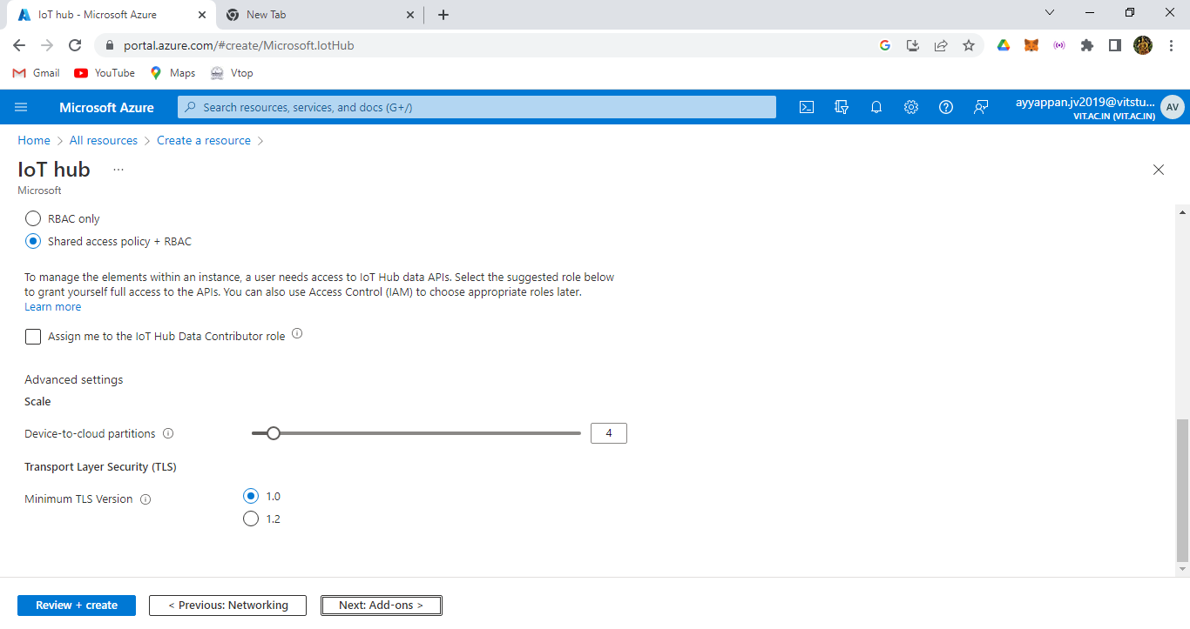

Here finally after creating all the details of IOT hub and hence validation also passed then click create option.

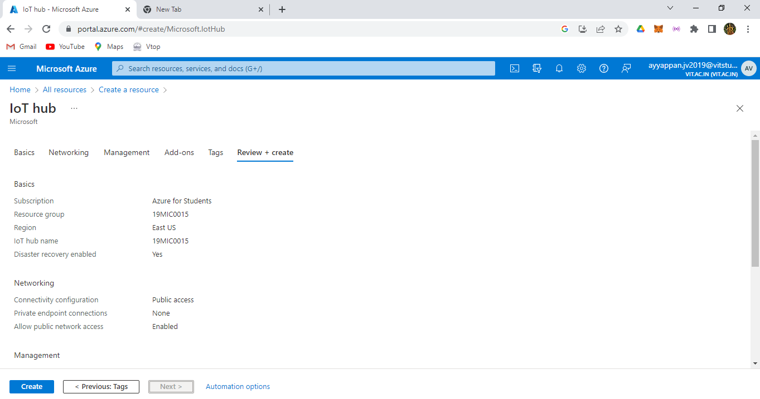

After creating the deployment has been deployed successfully.

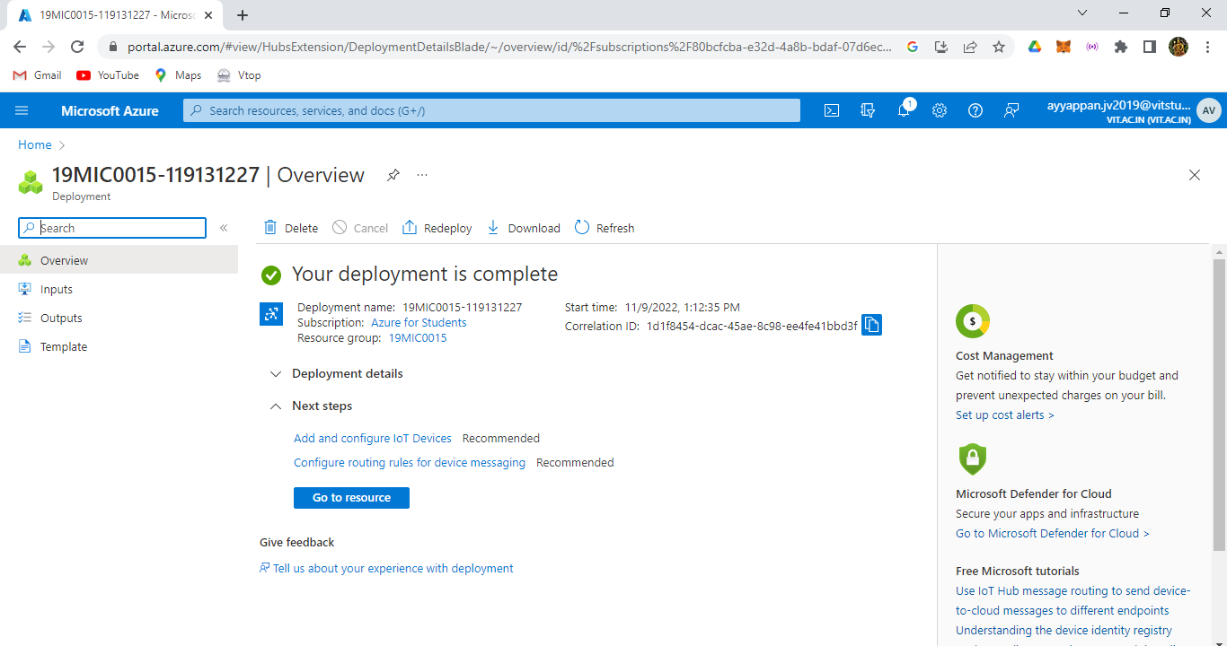

Then we have the resource part of the IOT hub in the Azure.

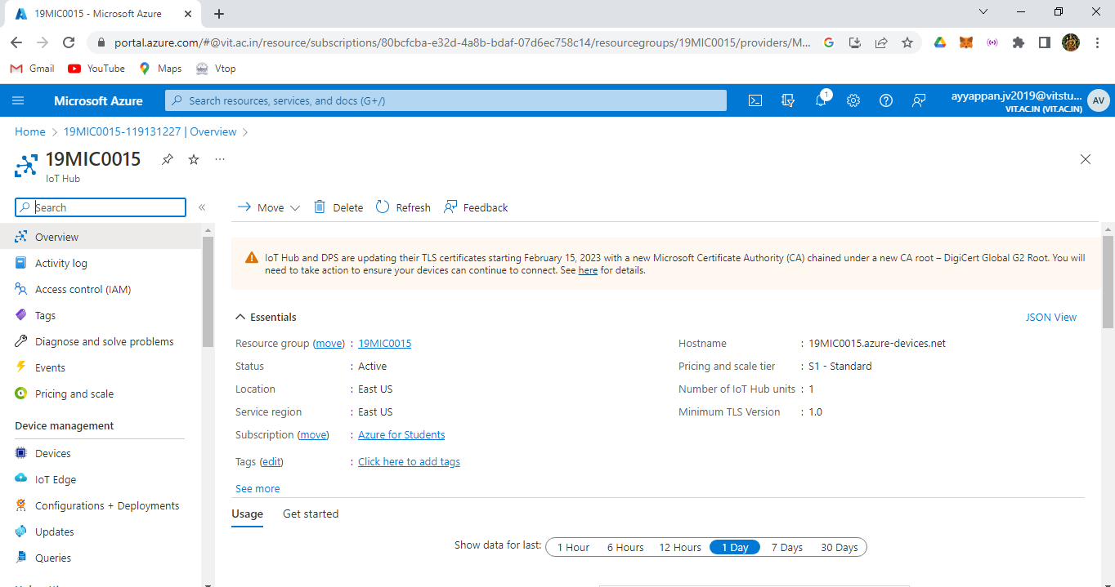

Then search as shared access policies and click add shared access policy.

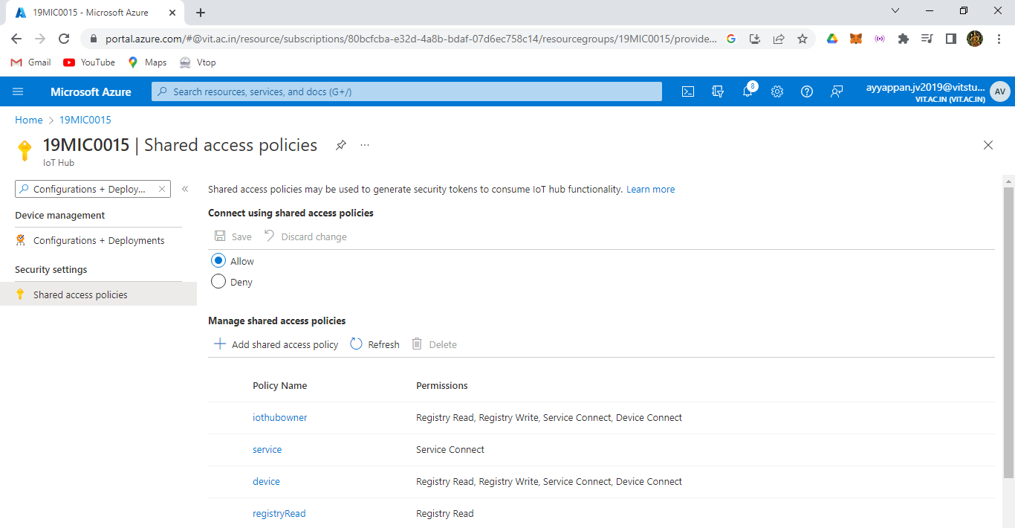

Then we have created the 19MIC0015 as an SAS policies.

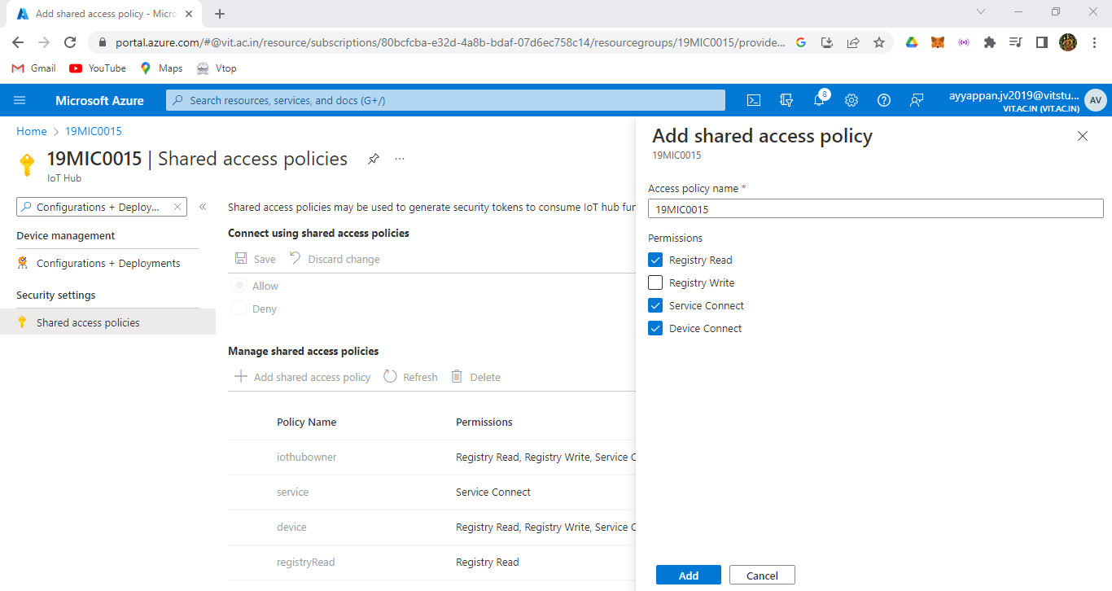

Then after creating we have the SAS token for configuring into the MQTT.

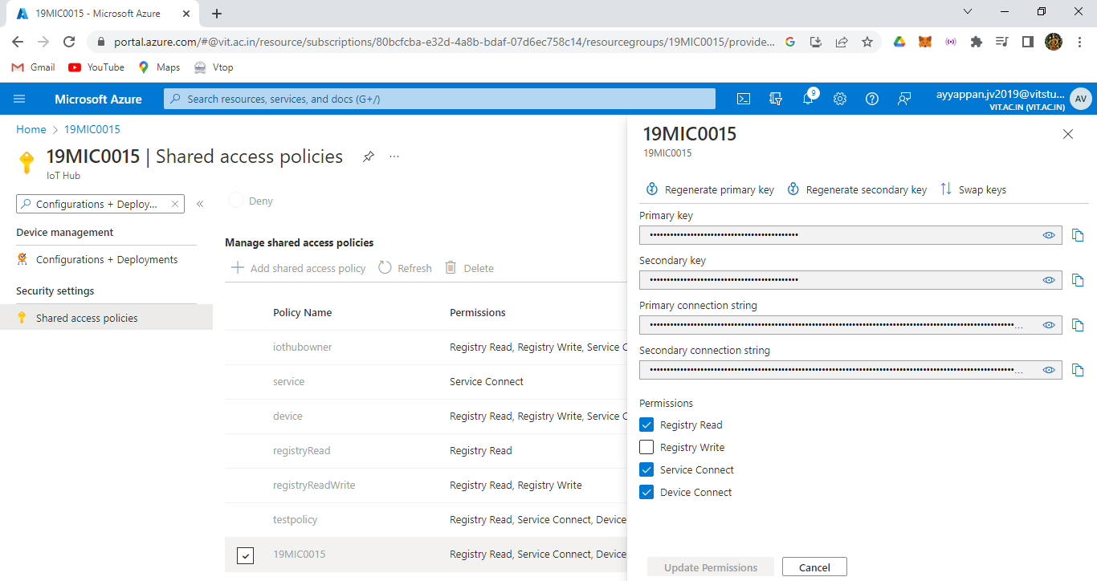

Here search as Device and click as add device option.

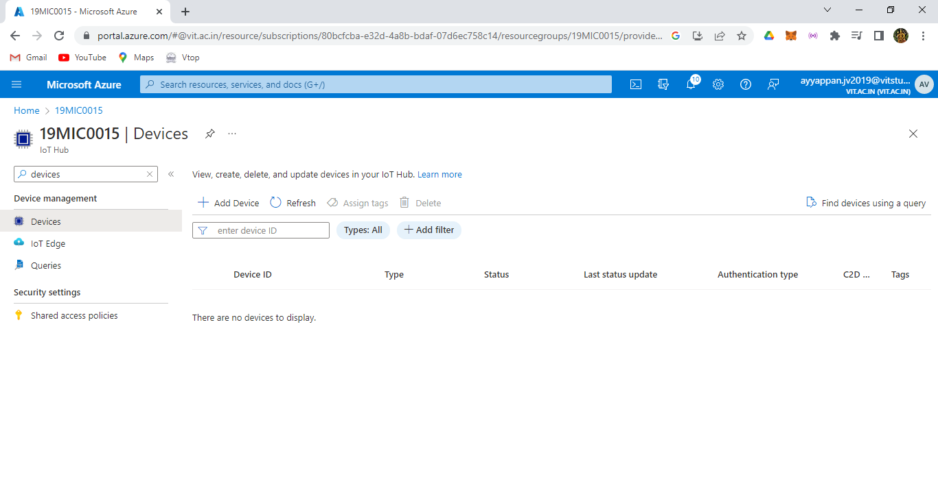

Here enter the device id and ID is 19MIC0015 and click save option.

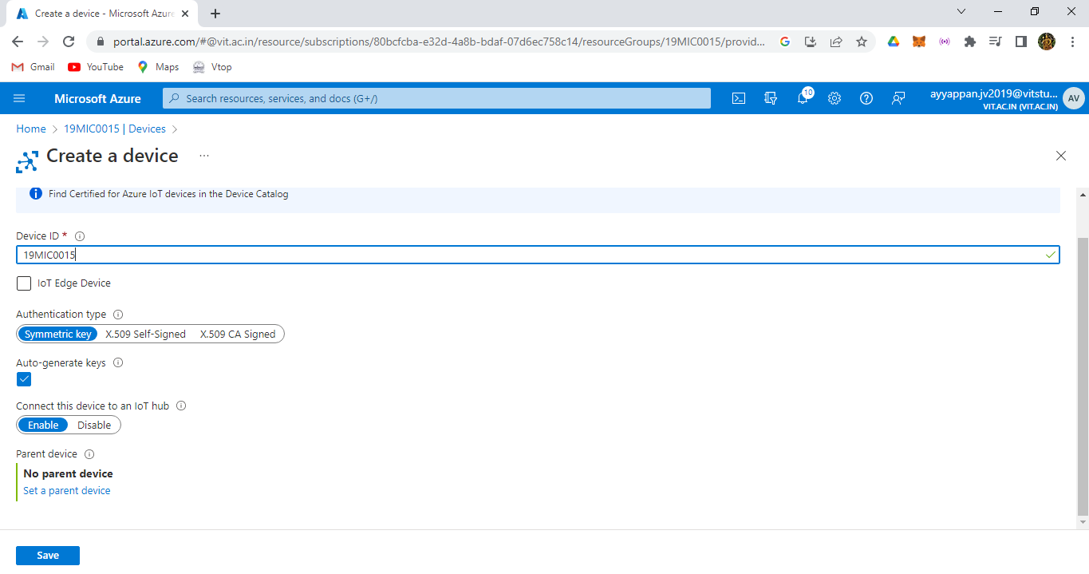

Here we can the devices which is created successfully.

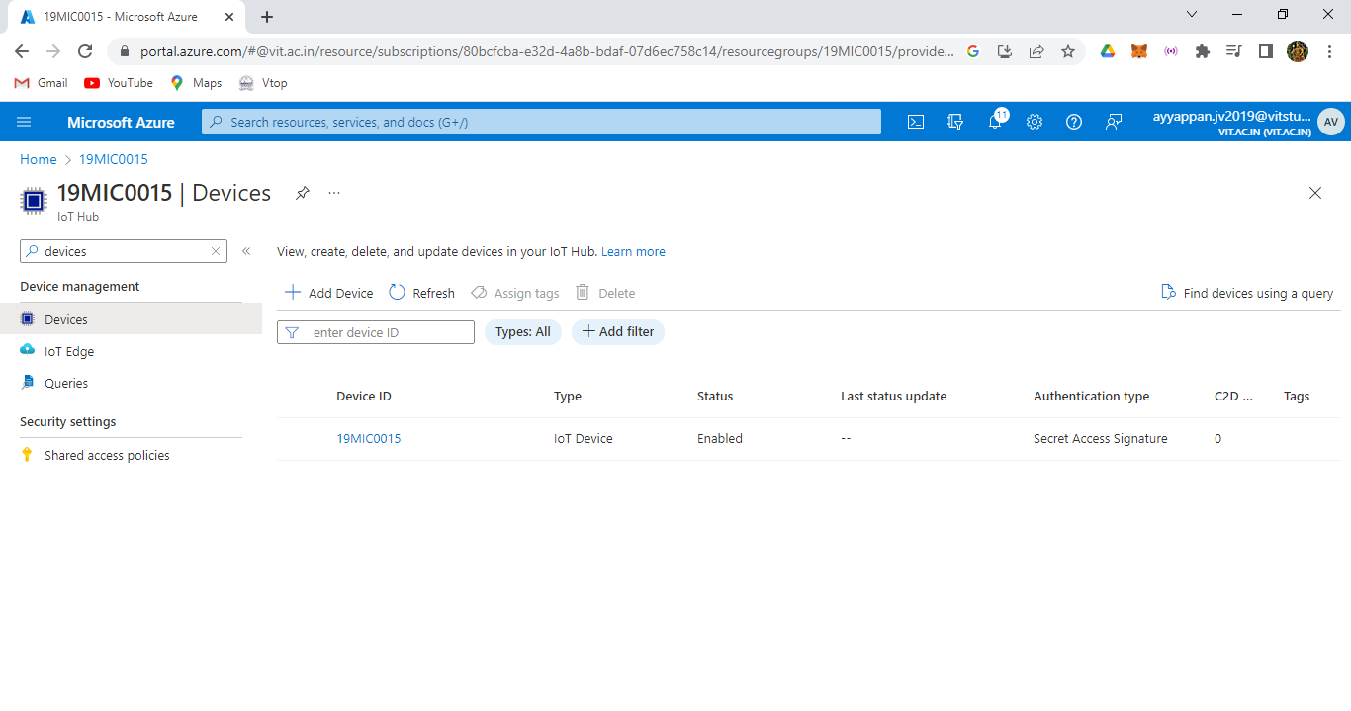

And then take the secondary connection string or copy it.



Then open device explorer and paste those token in the IOT hub connection string, and click as update.

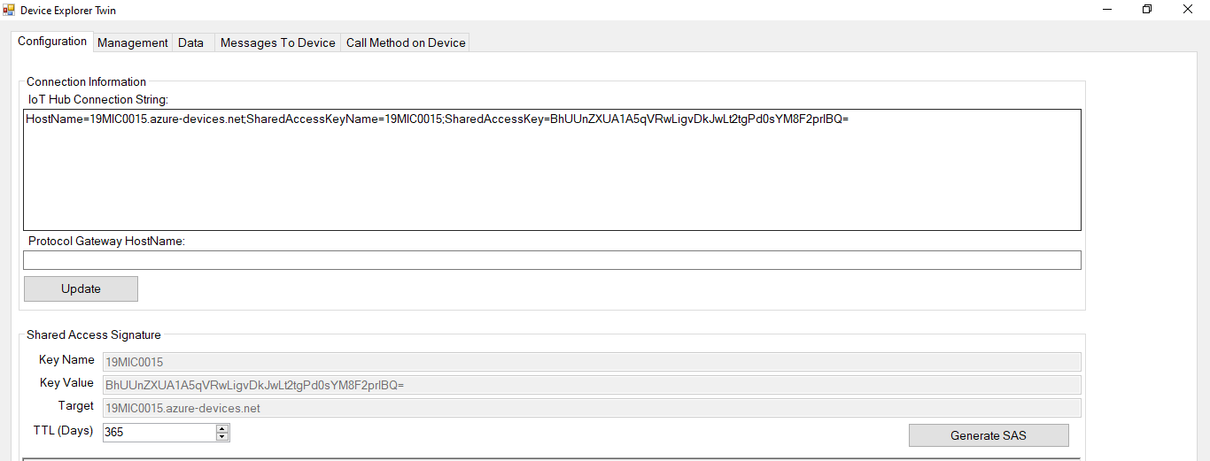

Here the string gets updated successfully.

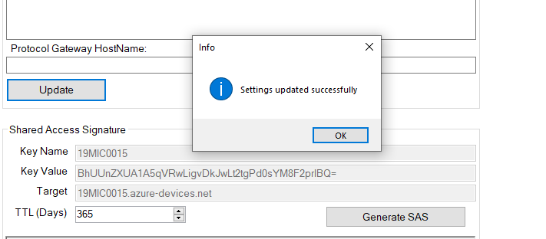

Then open MQTT box and click on MQTT client and enter those details followed by the output of the picture.

Host : Device-ID on azure

Username : IOT HUB name.azure-devices.net/Device-ID/?api-version=2018-12-30

Password : where u get the SAS token is generated on the device explorer twin box.

Paste those shared access signature.

MQTT client id as device id On the azure,

Keep protocol as mqtt/tls & SSL as CA signed server certificate,

Timestamp to mqtt client id NO.

QOS as atleast once.

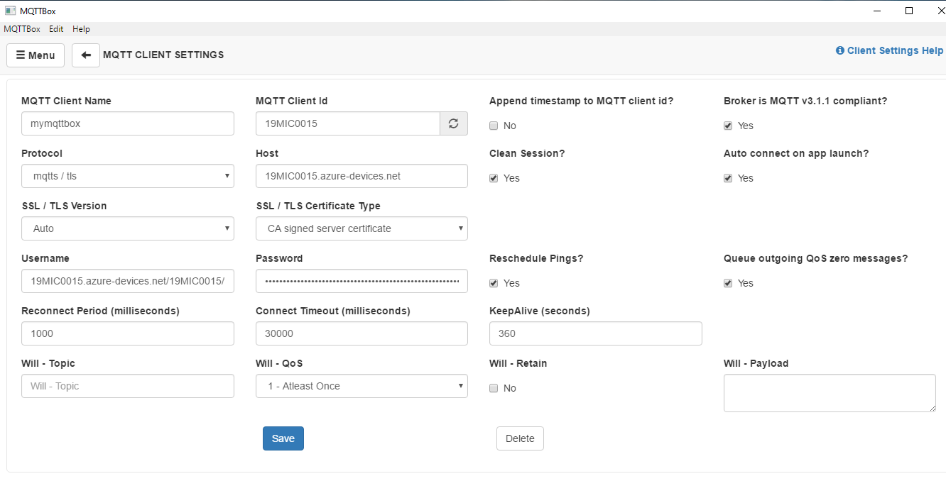

Then click save option.

Hence we get the MQTT is connected to the IOT hub on azure successfully.

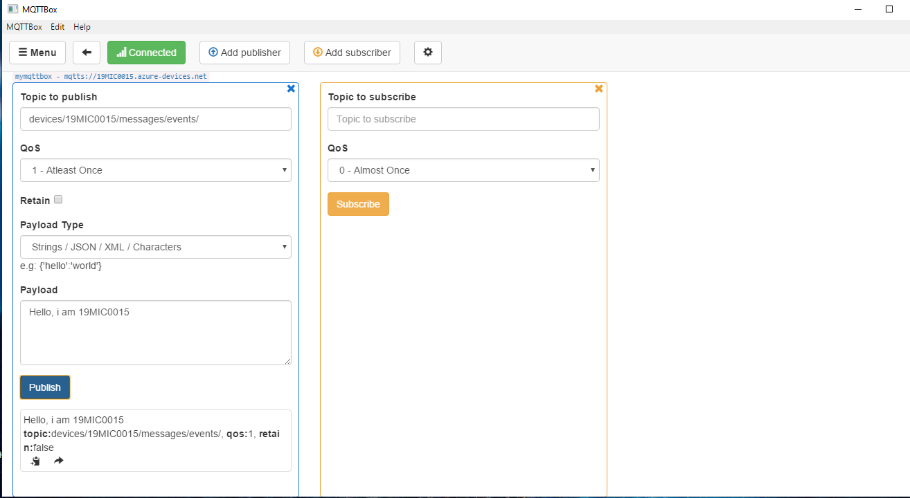

Then in publish assign as devices/19MIC0015/messages/events/

Enter the payload message and publish the output is displayed.

We can see the 19MIC0015 is connected to the IOT Hub using mqtt.

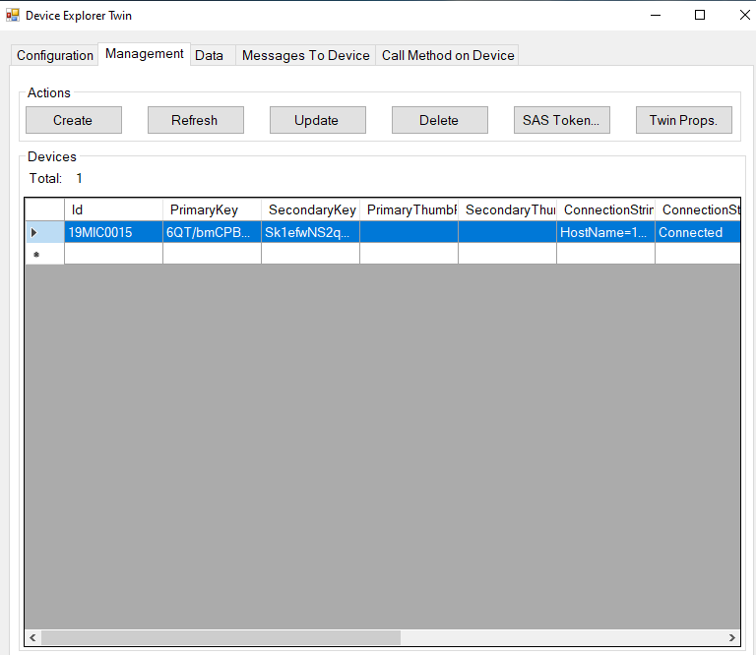

Now click on the data option and select the device id and click on monitor option we get the event hub data as output of it.

